Hindu Calendars
# Source: AI Source: Provided by: [Data Path: Persons Table -> ID Column: 1, Name_En Column: Motasem Essam] -> From: [ChatGPT] on [7/17/2026]
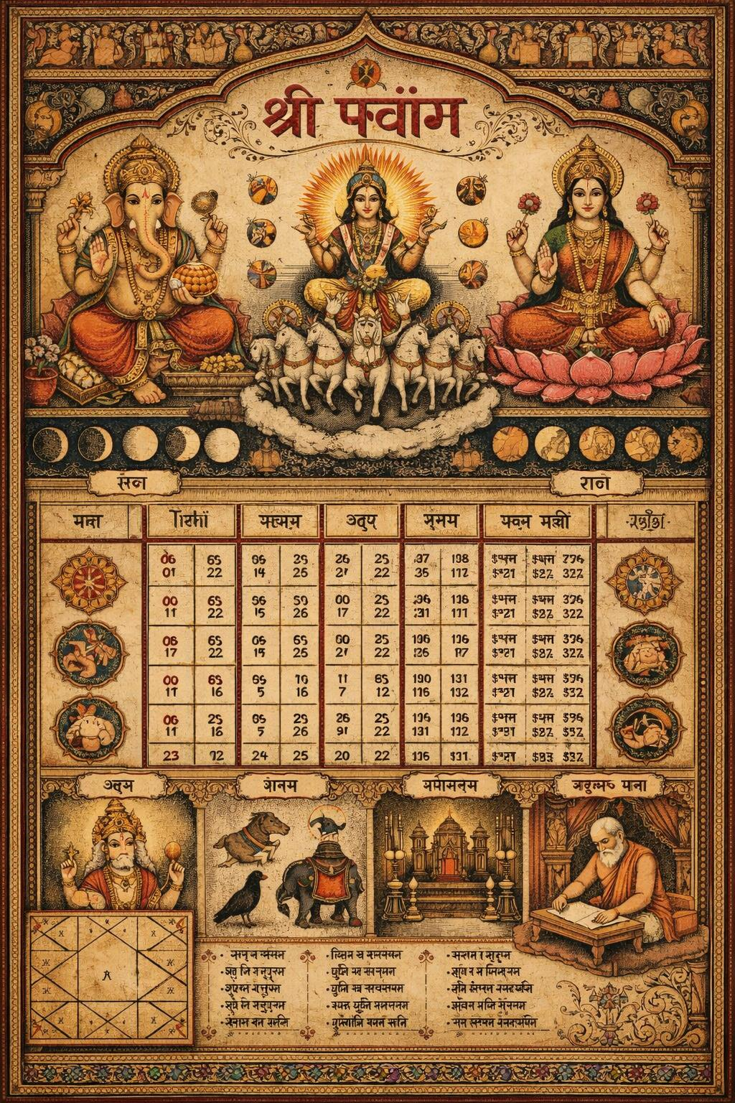
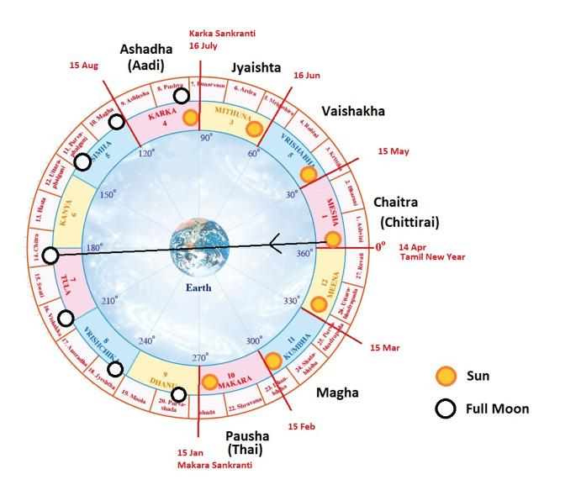
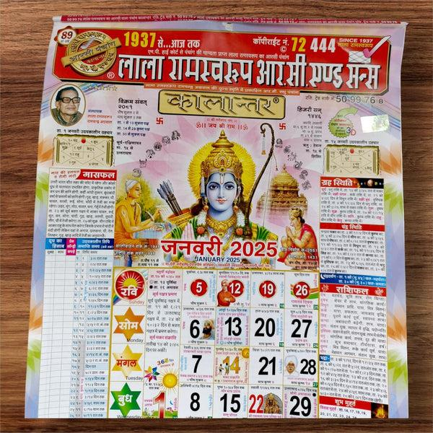
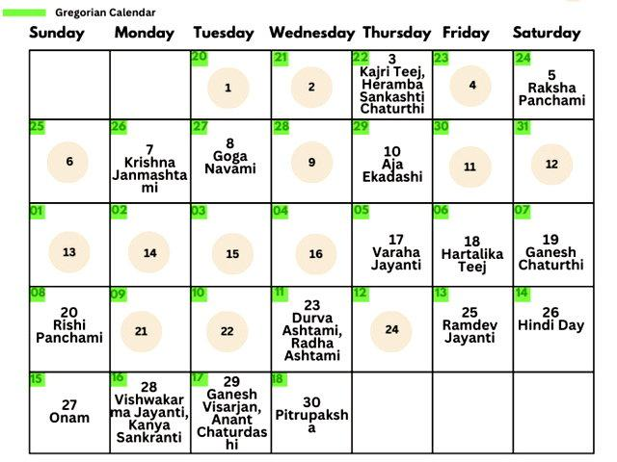
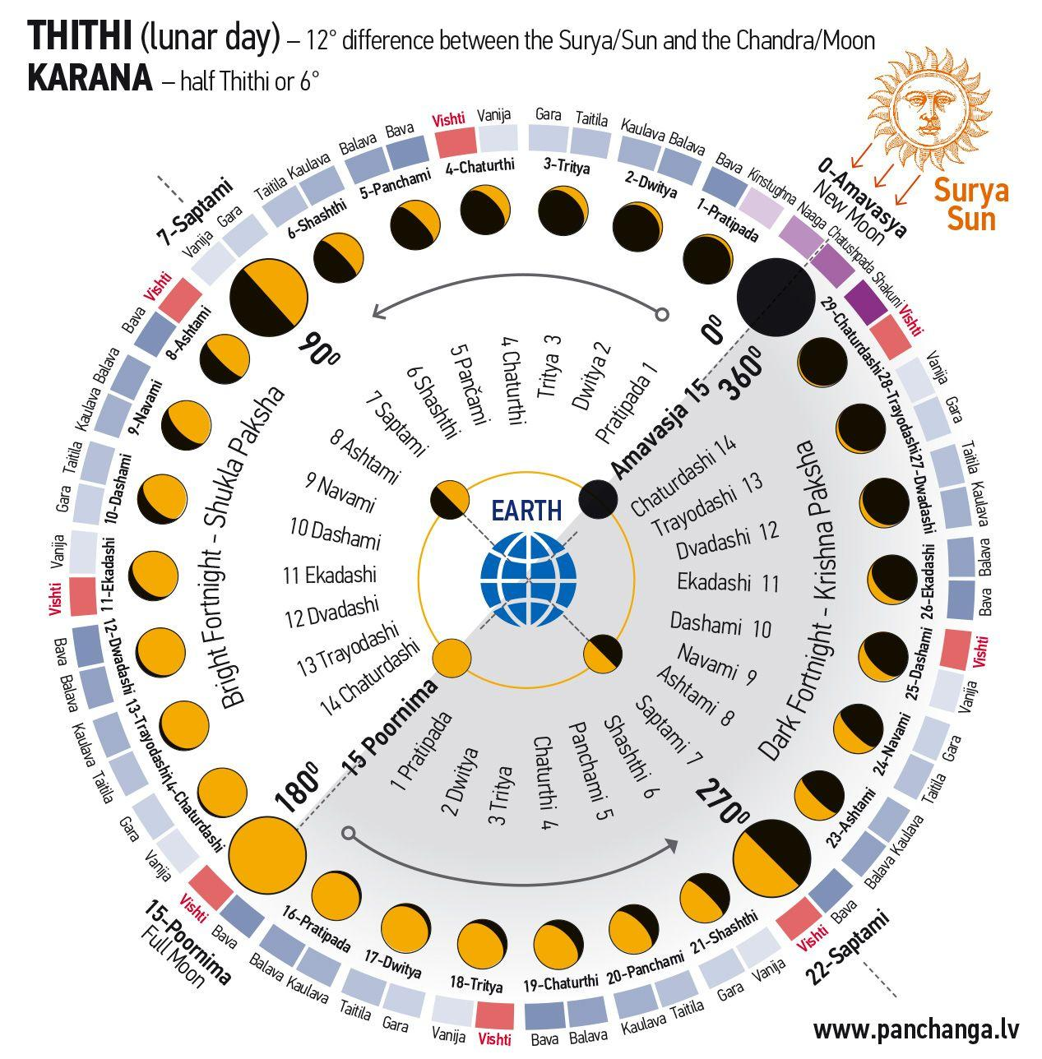
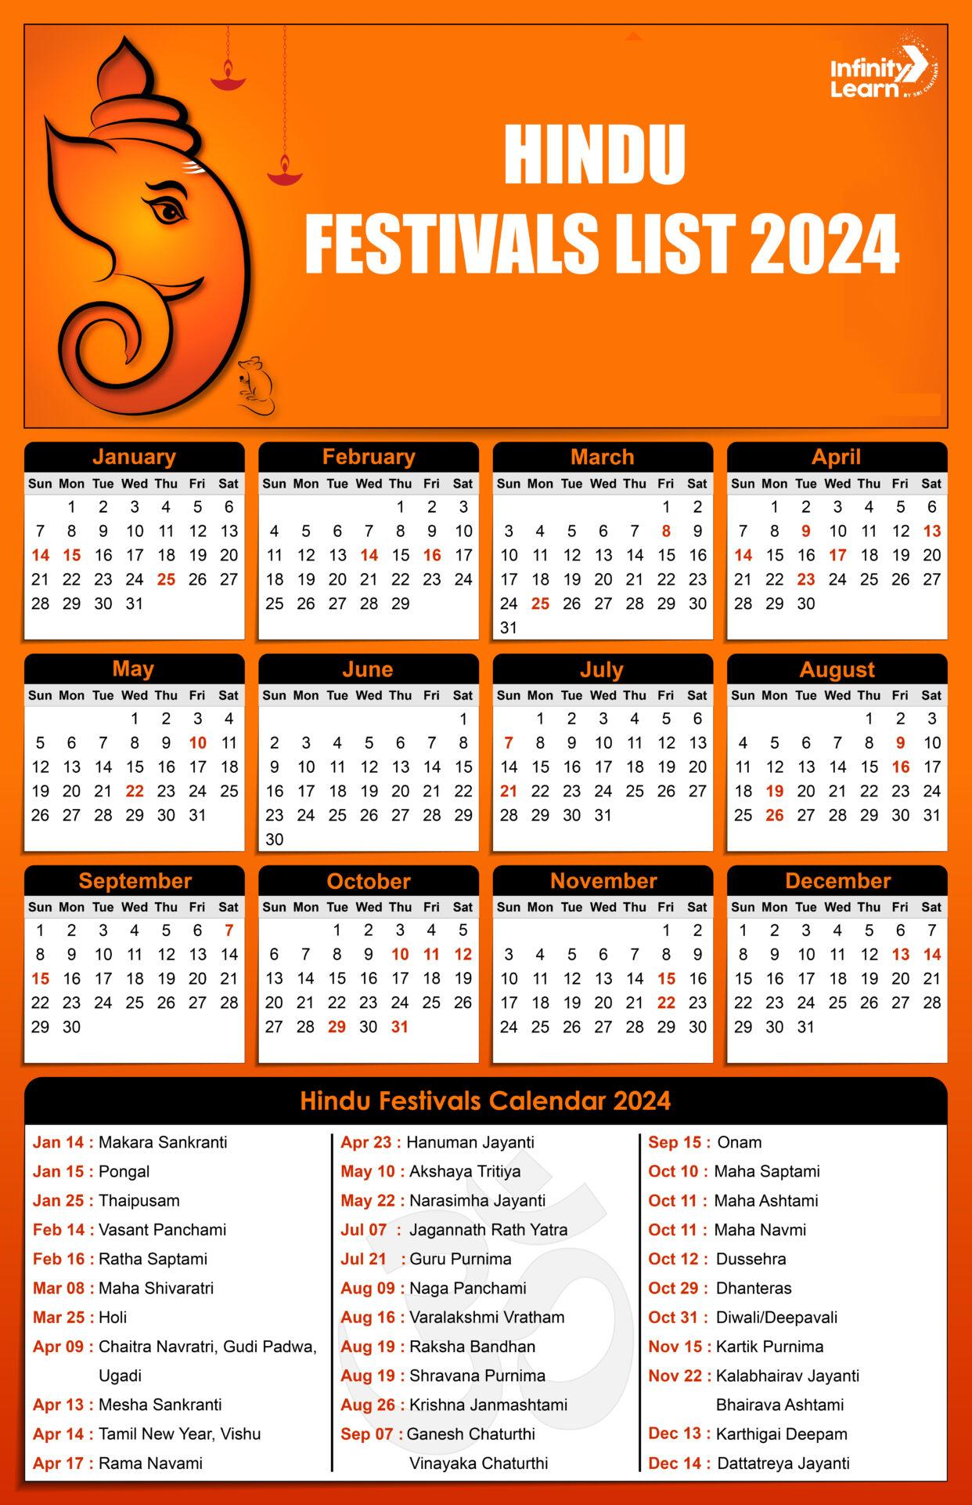
The Hindu Calendars are a family of lunisolar calendars traditionally used across India and Nepal to determine religious festivals, auspicious dates, rituals, and traditional observances. Unlike a single standardized calendar, there are multiple regional Hindu calendars, each sharing common astronomical principles while differing in month names, year numbering, and methods of calculation.
Hindu calendars combine the phases of the Moon with the solar year, using leap months to keep lunar months aligned with the seasons.

Definition
# Source: AI Source: Provided by: [Data Path: Persons Table -> ID Column: 1, Name_En Column: Motasem Essam] -> From: [ChatGPT] on [7/17/2026]
Hindu Calendars are traditional lunisolar calendar systems that combine lunar months with the solar year to determine religious, cultural, and seasonal events in Hindu traditions.

Purpose
# Source: AI Source: Provided by: [Data Path: Persons Table -> ID Column: 1, Name_En Column: Motasem Essam] -> From: [ChatGPT] on [7/17/2026]
Hindu calendars are used to:
- Determine Hindu religious festivals.
- Schedule religious ceremonies.
- Identify auspicious dates (Muhurta).
- Observe fasting days.
- Plan weddings and rituals.
- Organize agricultural and seasonal activities.

Type of Calendar
# Source: AI Source: Provided by: [Data Path: Persons Table -> ID Column: 1, Name_En Column: Motasem Essam] -> From: [ChatGPT] on [7/17/2026]
The Hindu calendar is a:
- Lunisolar Calendar
It is based on:
- Lunar months (Moon's phases)
- Solar year (Earth's revolution around the Sun)

Astronomical Basis
# Source: AI Source: Provided by: [Data Path: Persons Table -> ID Column: 1, Name_En Column: Motasem Essam] -> From: [ChatGPT] on [7/17/2026]
The calendar combines:
Lunar Month
Average length:
$$29.5306\text{ days}$$
Solar Year
Average length:
$$365.2422\text{ days}$$
Because twelve lunar months are about 11 days shorter than the solar year, a leap month is periodically inserted to maintain seasonal alignment.

Main Characteristics
# Source: AI Source: Provided by: [Data Path: Persons Table -> ID Column: 1, Name_En Column: Motasem Essam] -> From: [ChatGPT] on [7/17/2026]
Hindu calendars generally have:
- 12 lunar months
- 13 months in leap years
- 354–355 days in a common year
- 383–385 days in a leap year

Hindu Months
# Source: AI Source: Provided by: [Data Path: Persons Table -> ID Column: 1, Name_En Column: Motasem Essam] -> From: [ChatGPT] on [7/17/2026]
Although names vary slightly by region, the traditional lunar months are:
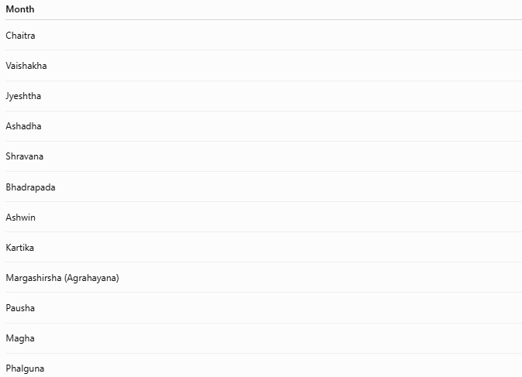
Month
Chaitra
Vaishakha
Jyeshtha
Ashadha
Shravana
Bhadrapada
Ashwin
Kartika
Margashirsha (Agrahayana)
Pausha
Magha
Phalguna

Leap Month (Adhik Maas)
# Source: AI Source: Provided by: [Data Path: Persons Table -> ID Column: 1, Name_En Column: Motasem Essam] -> From: [ChatGPT] on [7/17/2026]
A unique feature of Hindu calendars is the Adhik Maas ("Extra Month").
Purpose
It is added approximately every 2–3 years to keep the lunar calendar synchronized with the solar year.
Unlike the Gregorian Calendar, which adds one extra day, Hindu calendars add an entire month.

Regional Variations
# Source: AI Source: Provided by: [Data Path: Persons Table -> ID Column: 1, Name_En Column: Motasem Essam] -> From: [ChatGPT] on [7/17/2026]
There is no single Hindu calendar. Major regional traditions include:

1. Vikram Samvat
# Source: AI Source: Provided by: [Data Path: Persons Table -> ID Column: 1, Name_En Column: Motasem Essam] -> From: [ChatGPT] on [7/17/2026]
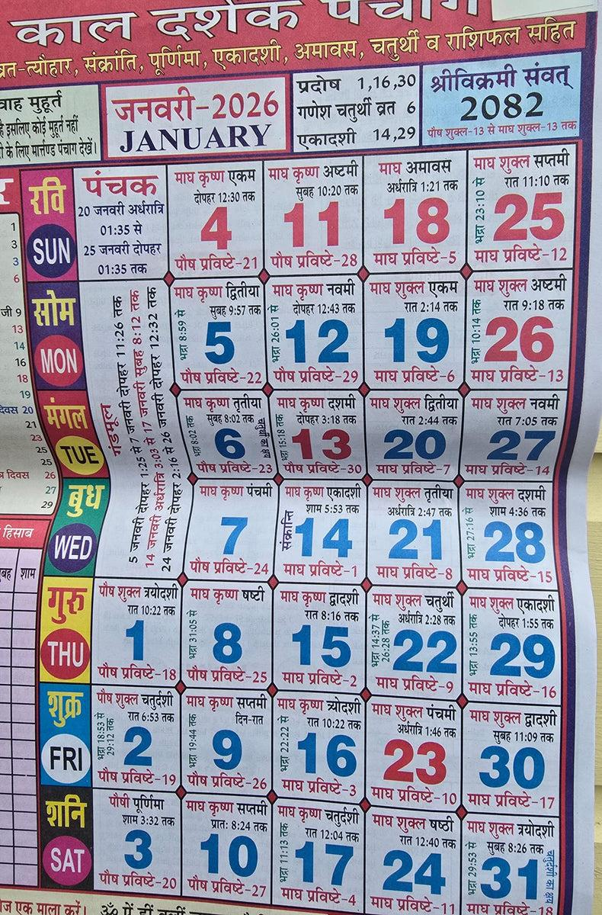
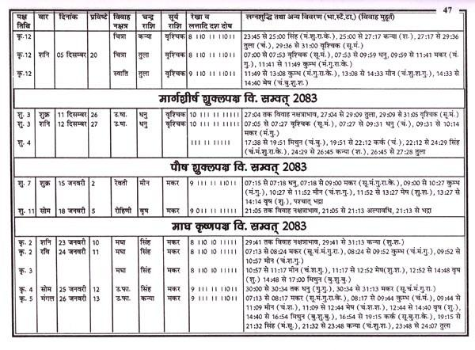
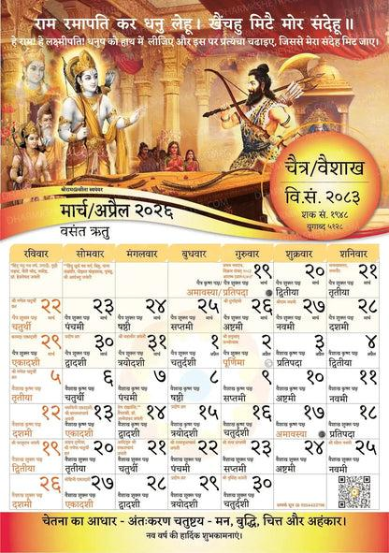
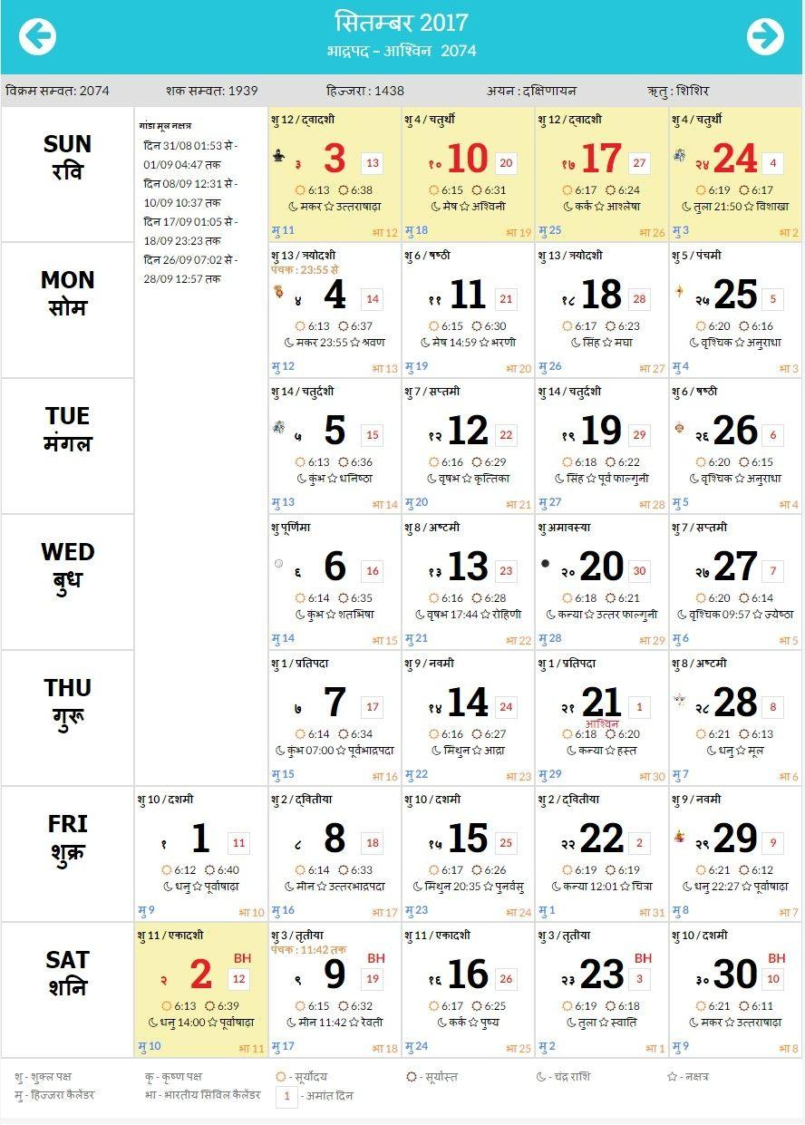
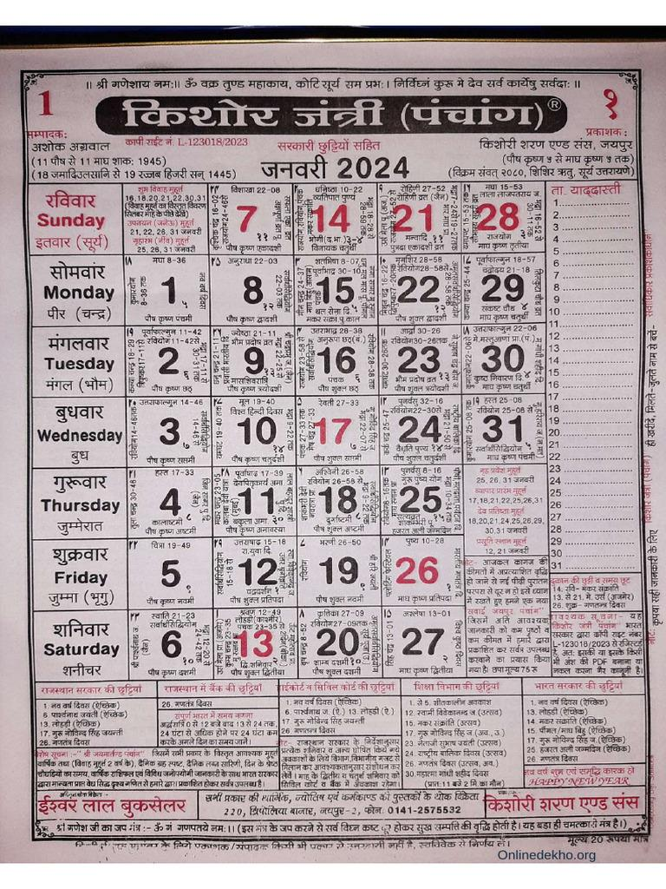
Characteristics
- Begins in 57 BCE
- Used in parts of northern and western India and officially in Nepal.
- Lunisolar calendar.

2. Shaka Calendar
# Source: AI Source: Provided by: [Data Path: Persons Table -> ID Column: 1, Name_En Column: Motasem Essam] -> From: [ChatGPT] on [7/17/2026]
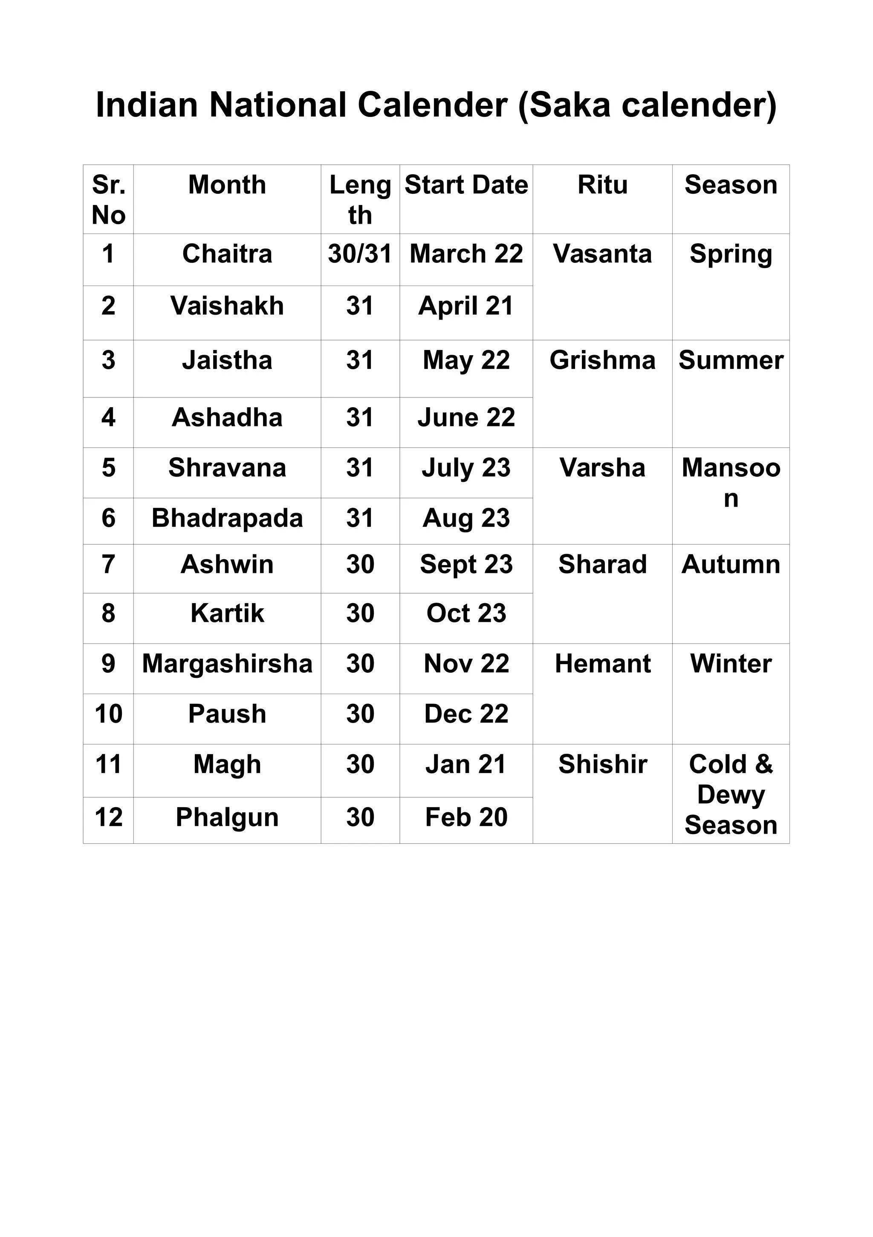
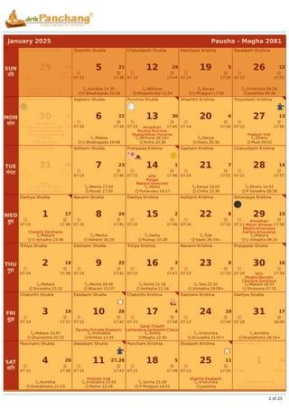
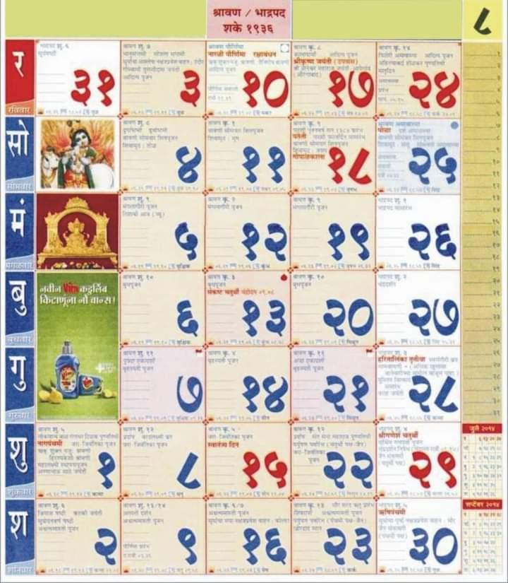
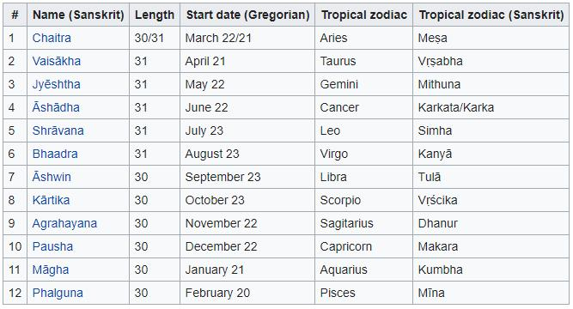
Characteristics
- Begins in 78 CE
- Official national calendar of India for certain government purposes.
- Solar-based civil version derived from traditional Hindu astronomy.

3. Tamil Calendar
# Source: AI Source: Provided by: [Data Path: Persons Table -> ID Column: 1, Name_En Column: Motasem Essam] -> From: [ChatGPT] on [7/17/2026]
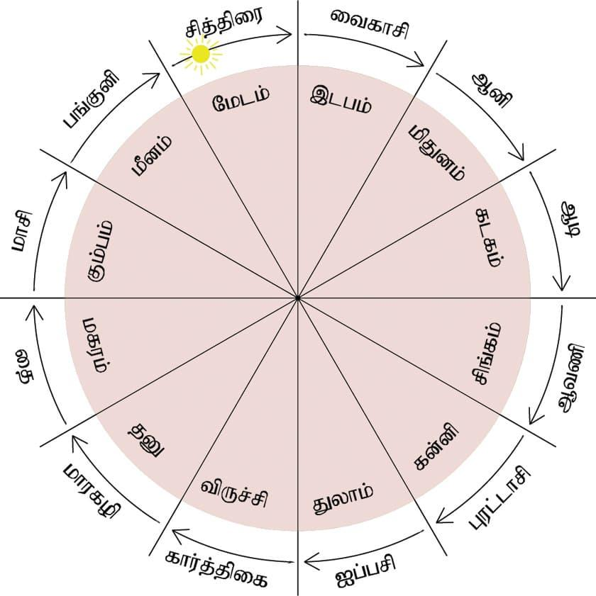
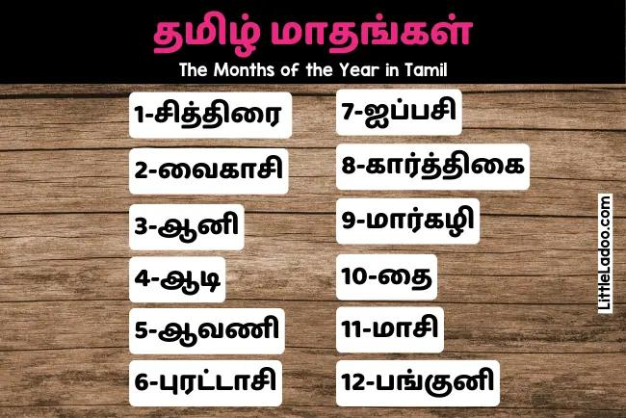
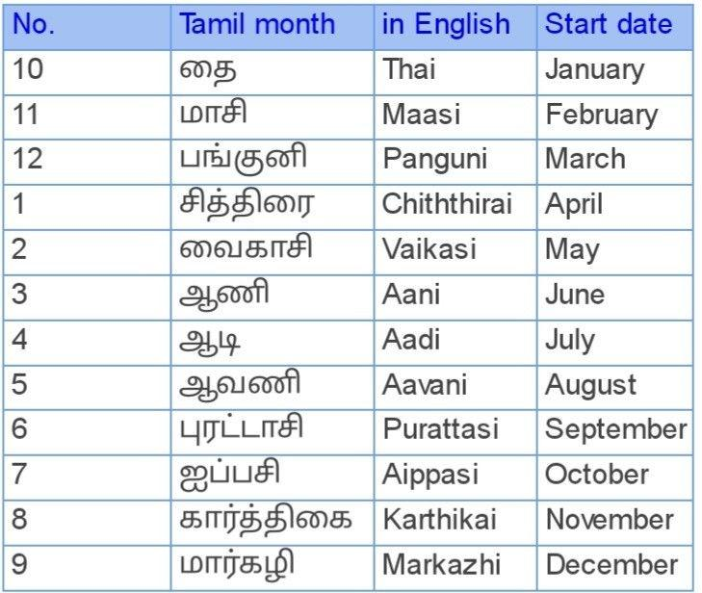
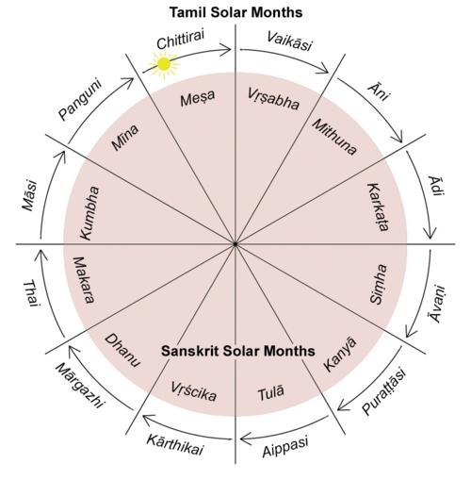
Characteristics
- Widely used in Tamil Nadu.
- Primarily solar.
- Used for religious and cultural observances.

4. Malayalam Calendar (Kollam Era)
# Source: AI Source: Provided by: [Data Path: Persons Table -> ID Column: 1, Name_En Column: Motasem Essam] -> From: [ChatGPT] on [7/17/2026]
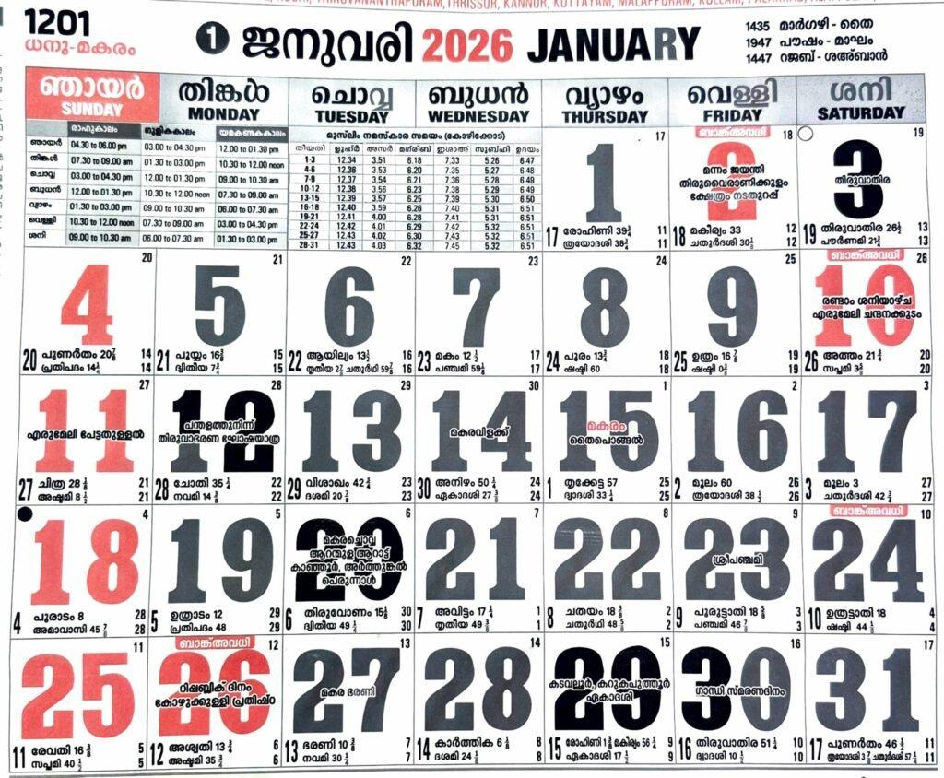
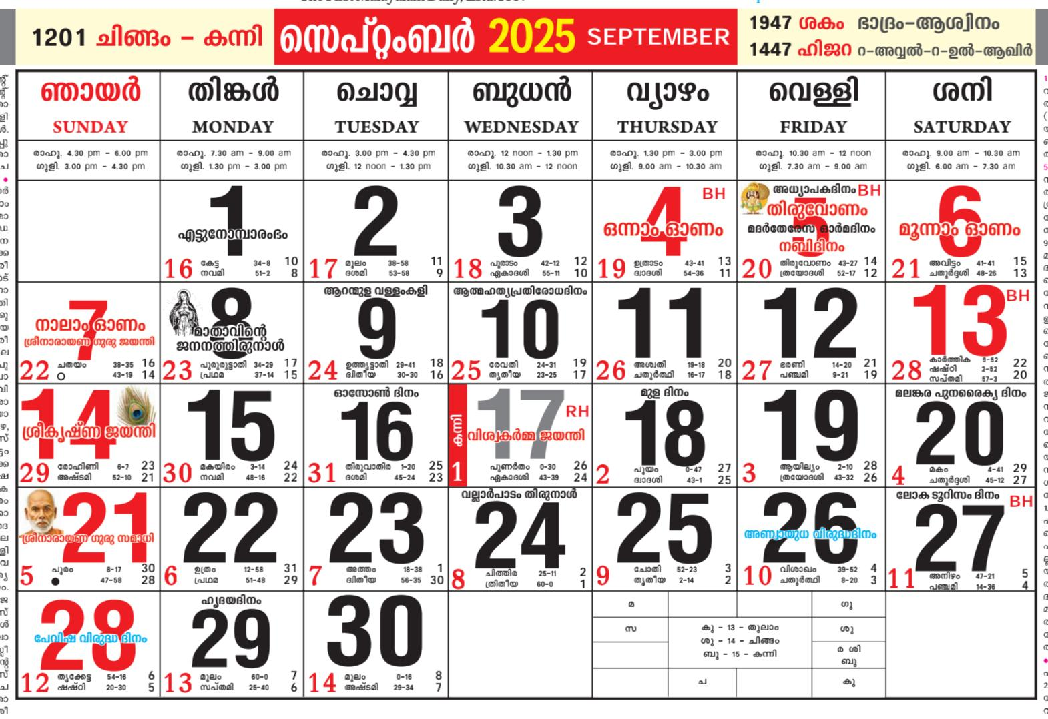
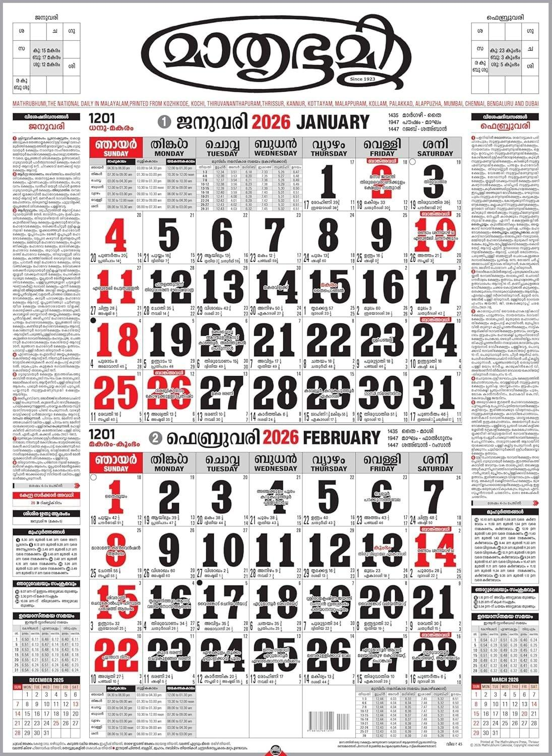
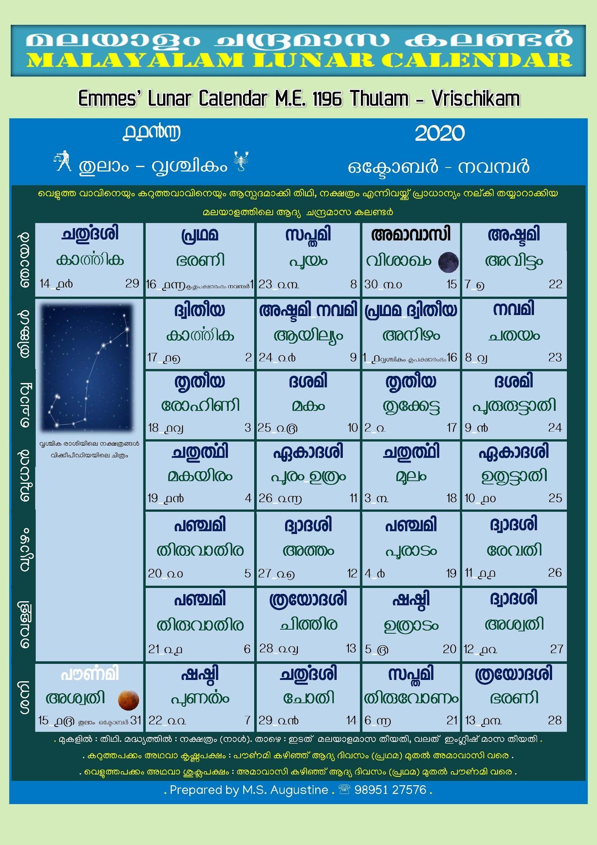
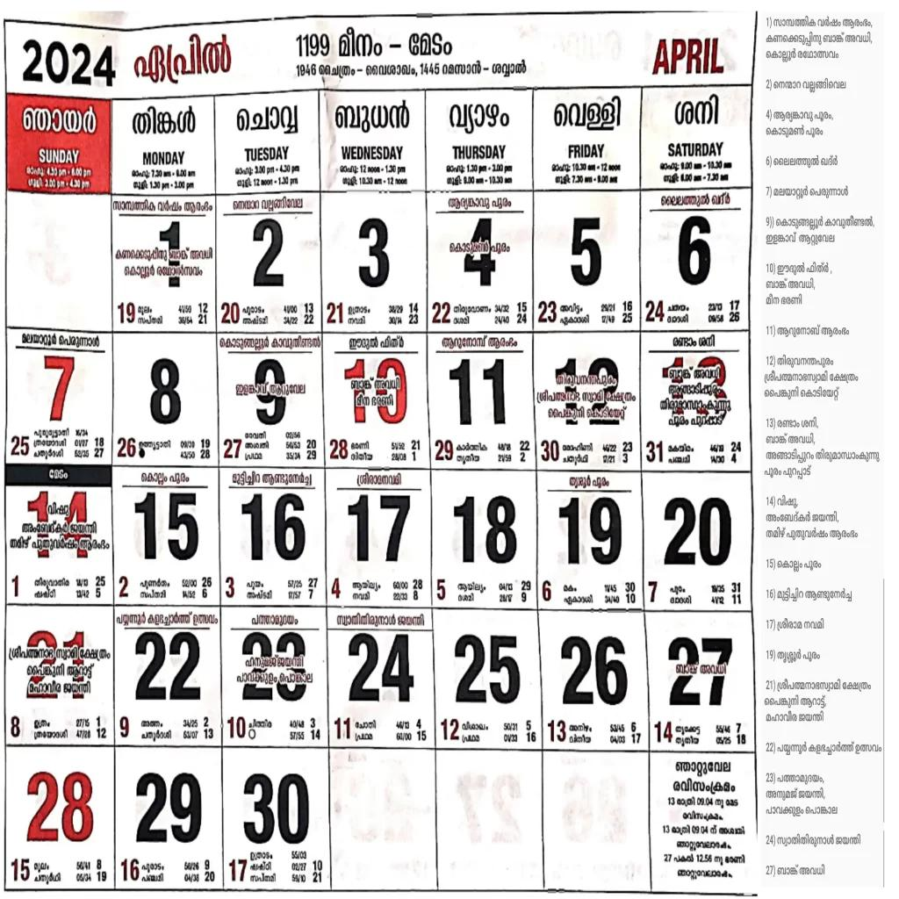
Characteristics
- Solar calendar.
- Used in Kerala.
- Important for regional festivals and agriculture.

5. Bengali Calendar
# Source: AI Source: Provided by: [Data Path: Persons Table -> ID Column: 1, Name_En Column: Motasem Essam] -> From: [ChatGPT] on [7/17/2026]
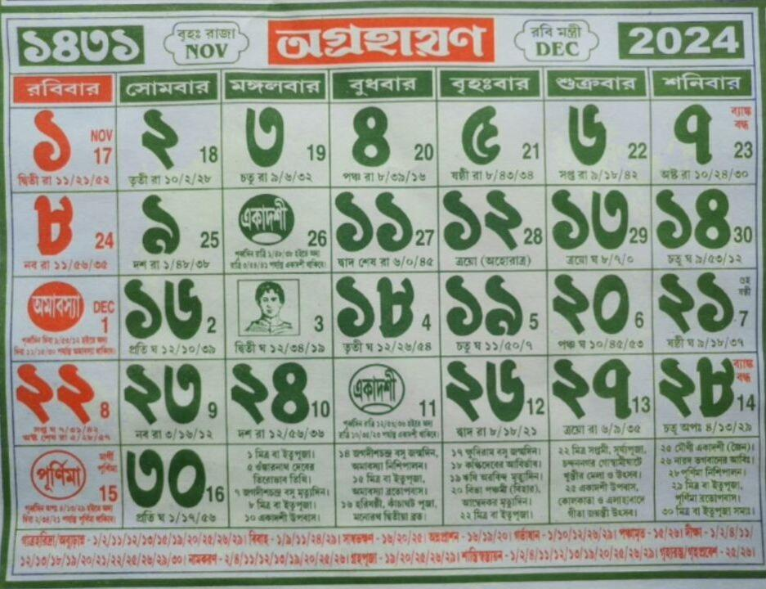
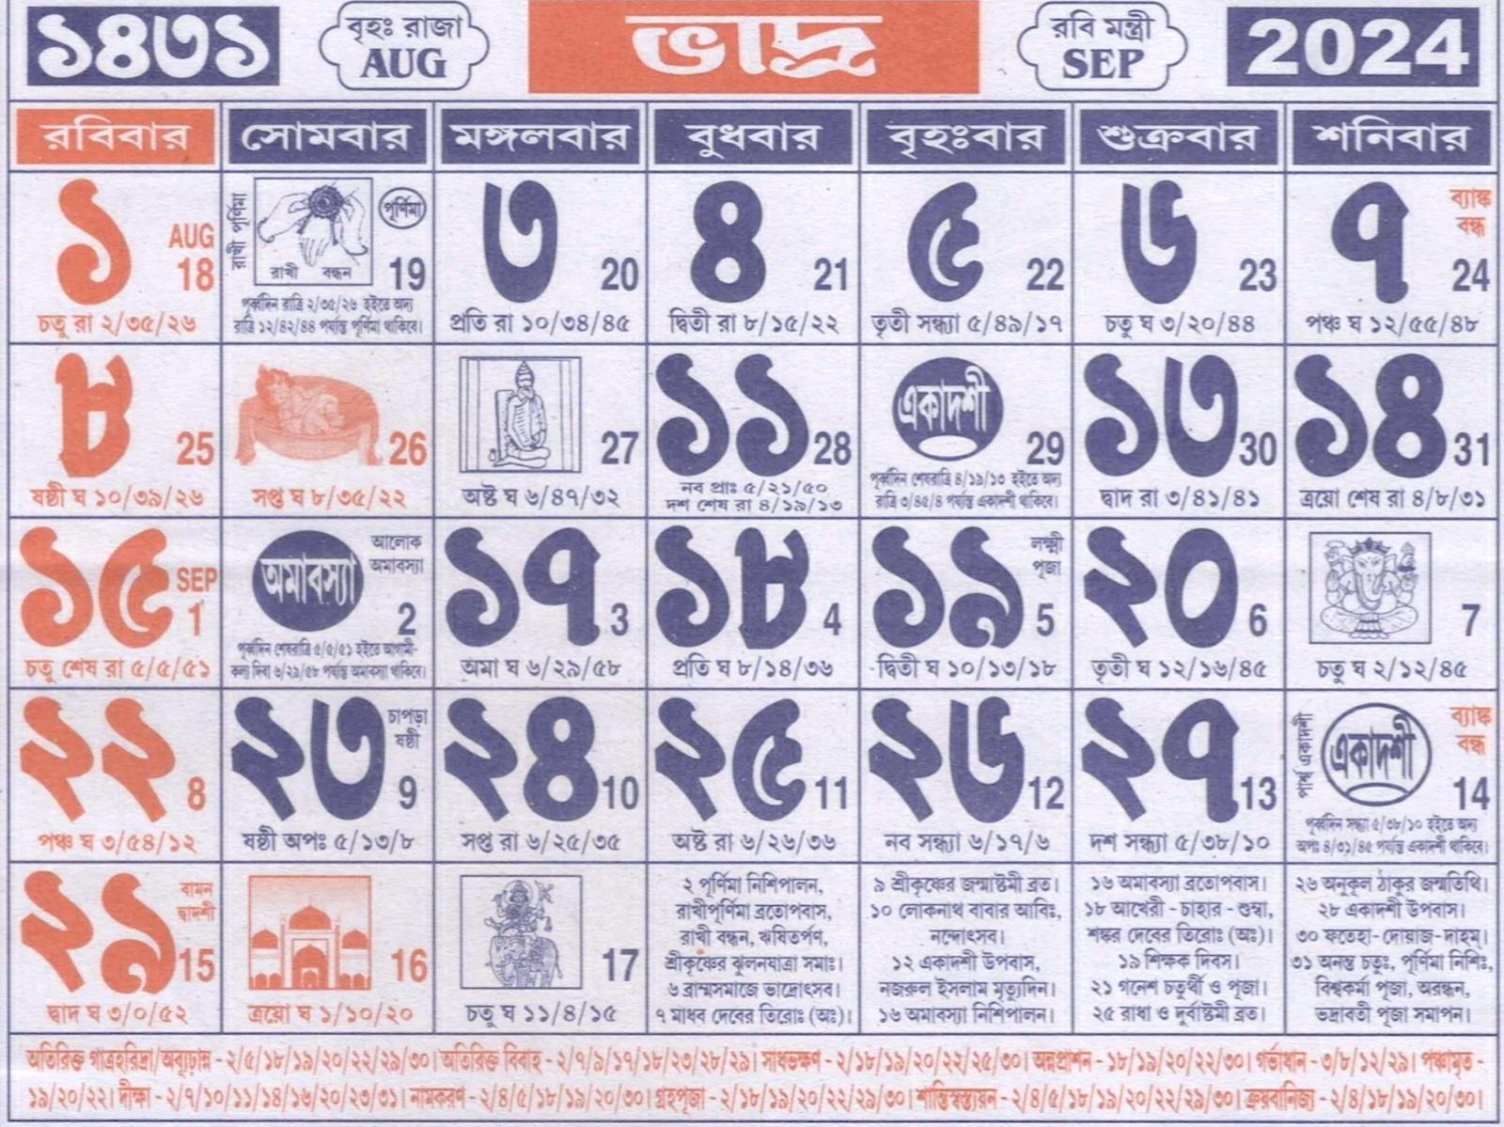
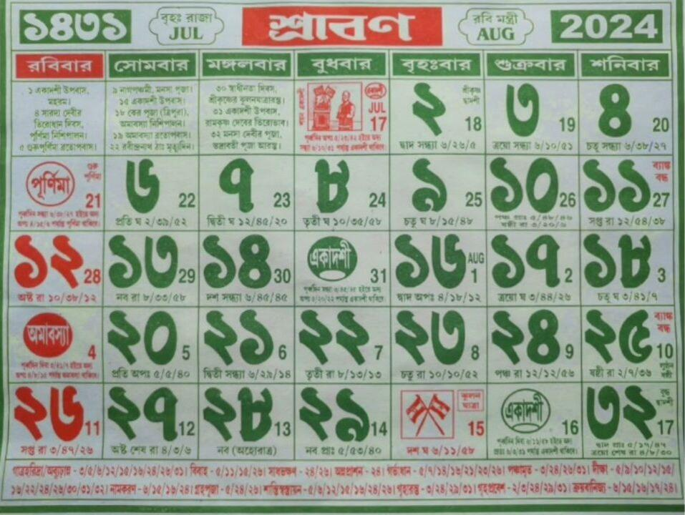
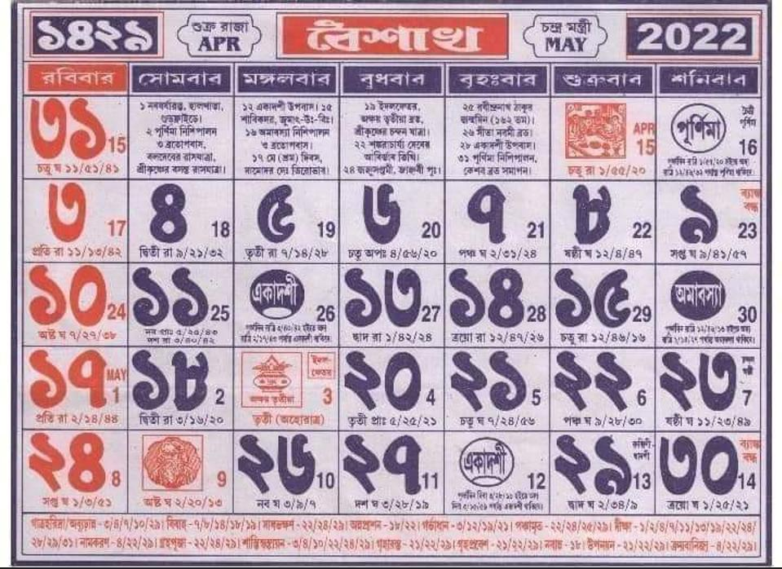
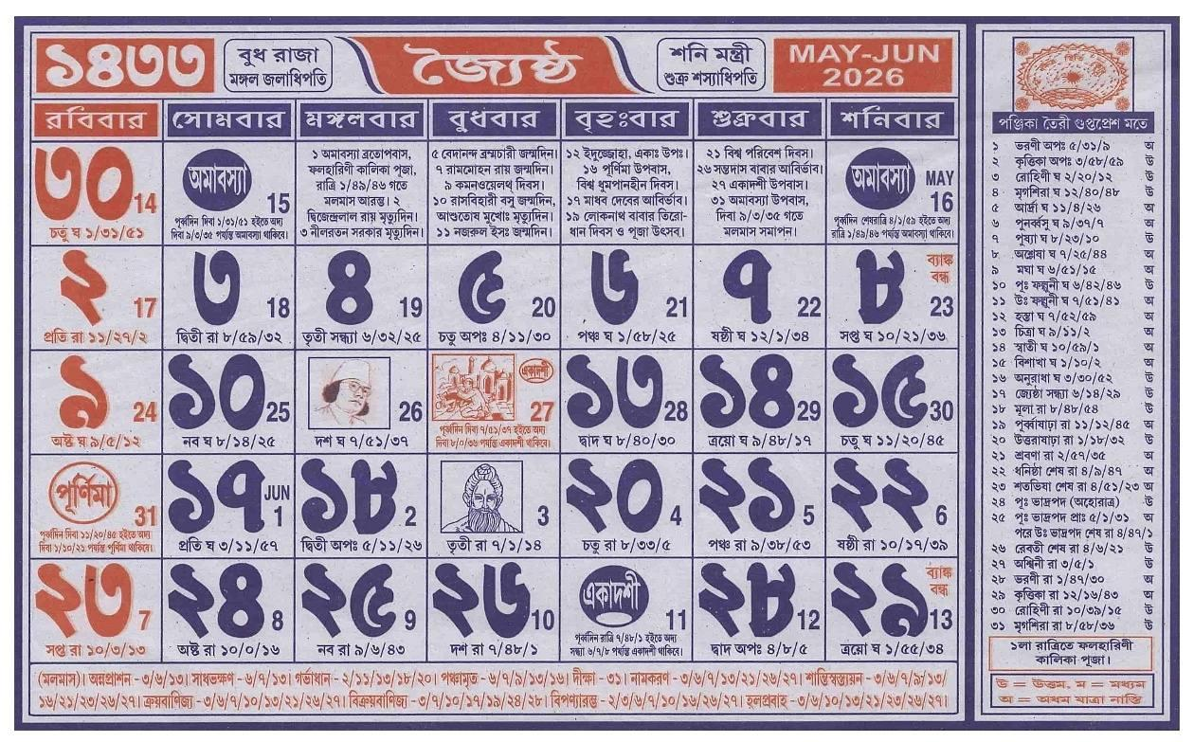
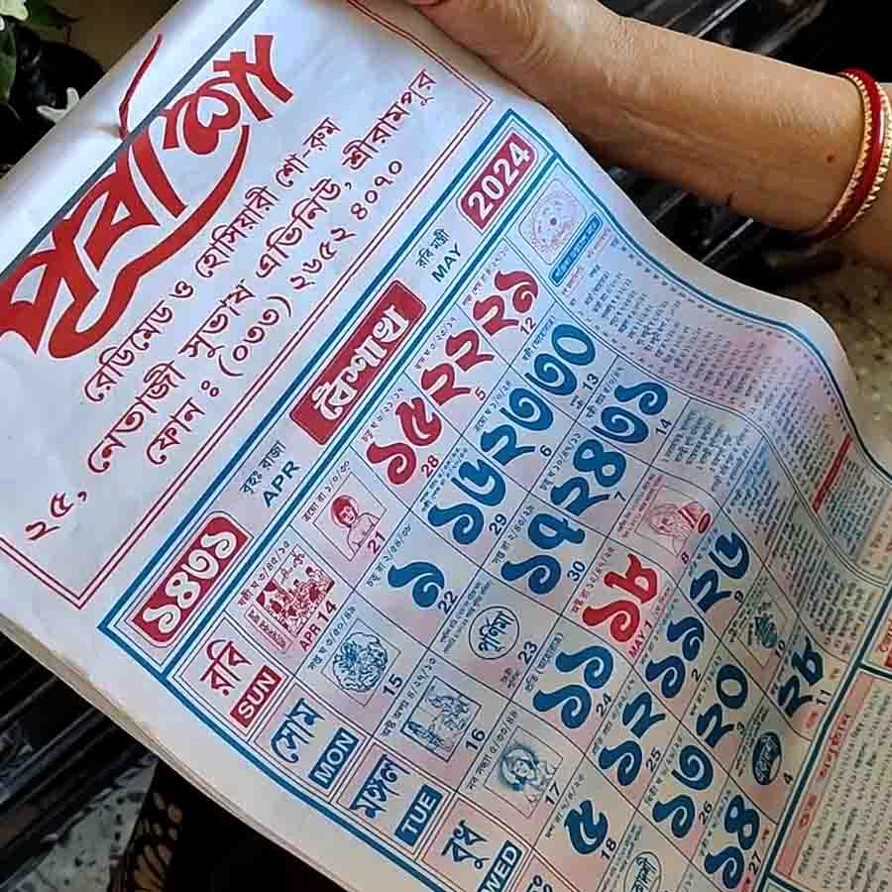
Characteristics
- Solar calendar with Hindu roots.
- Used in West Bengal and Bangladesh for cultural purposes.

Important Festivals Determined by Hindu Calendars
# Source: AI Source: Provided by: [Data Path: Persons Table -> ID Column: 1, Name_En Column: Motasem Essam] -> From: [ChatGPT] on [7/17/2026]
The calendar determines the dates of many Hindu festivals, including:
- Diwali
- Holi
- Navaratri
- Dussehra
- Maha Shivaratri
- Krishna Janmashtami
- Ganesh Chaturthi
- Raksha Bandhan
Because these festivals follow lunar dates, their Gregorian dates change each year.

Panchang
# Source: AI Source: Provided by: [Data Path: Persons Table -> ID Column: 1, Name_En Column: Motasem Essam] -> From: [ChatGPT] on [7/17/2026]
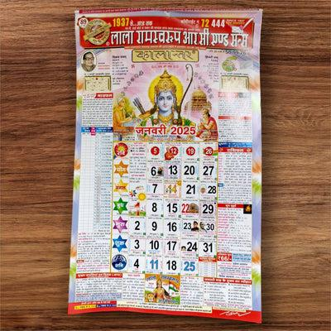
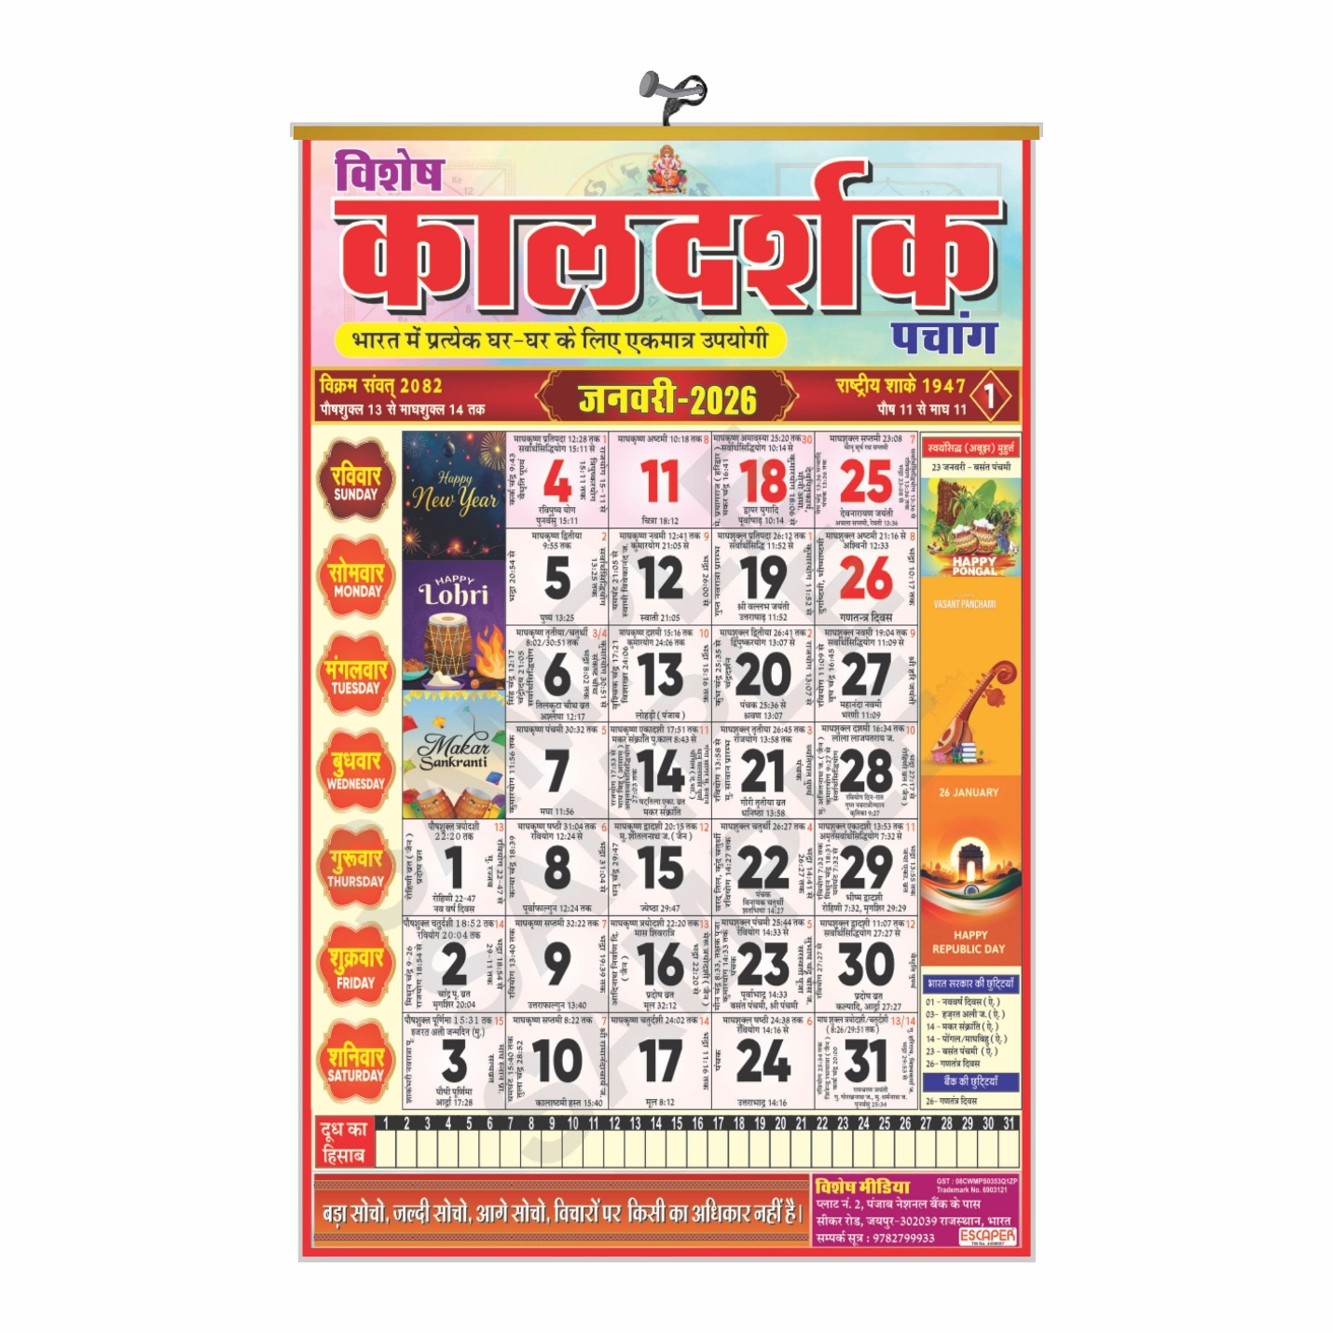
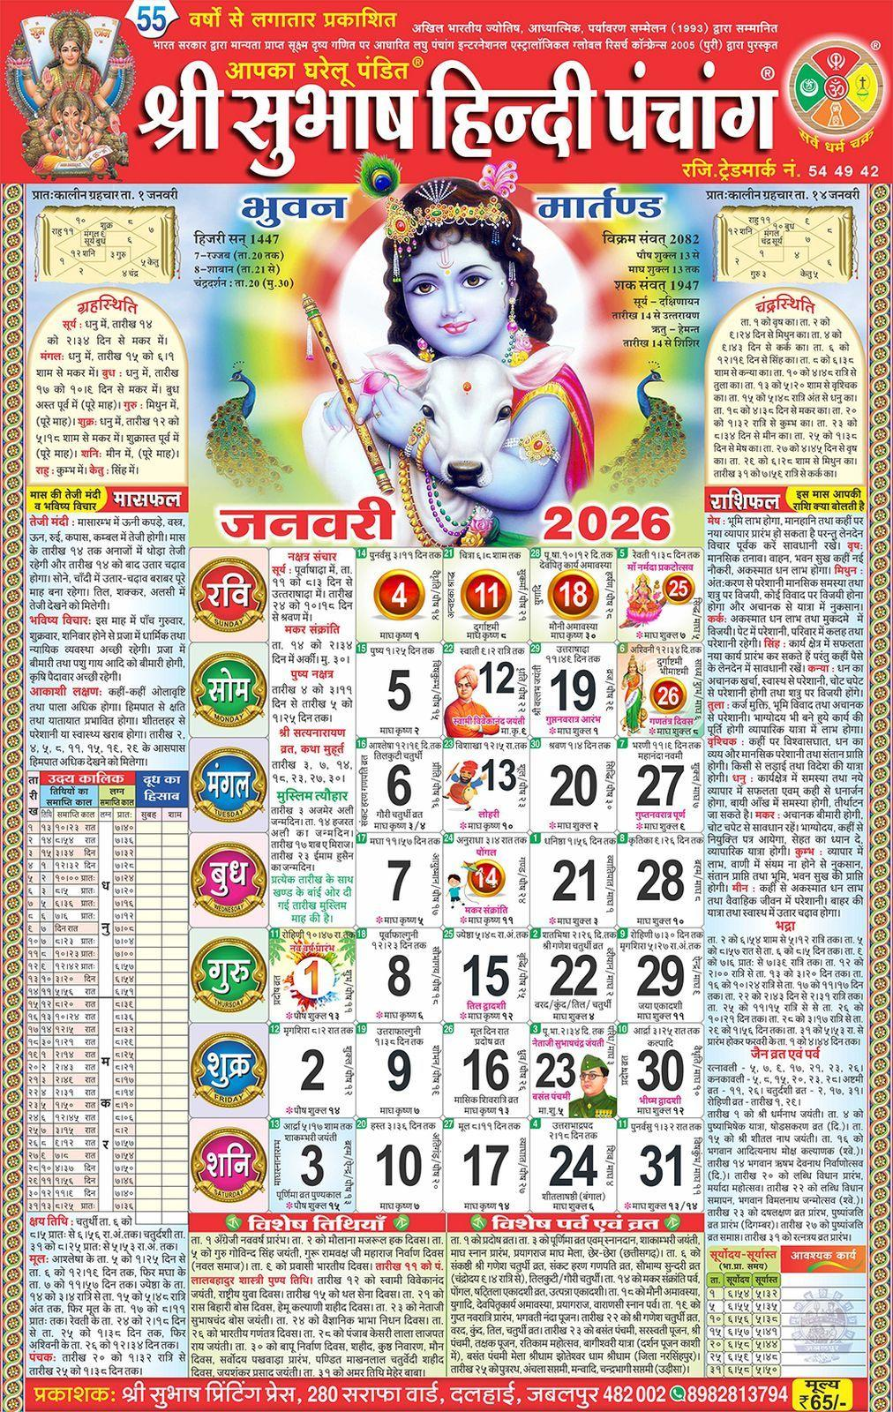
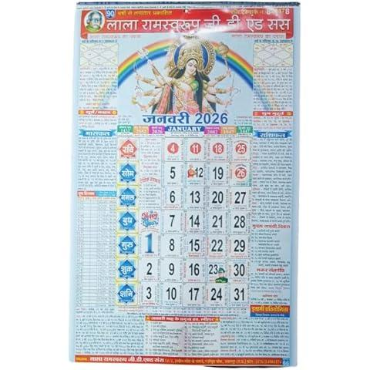
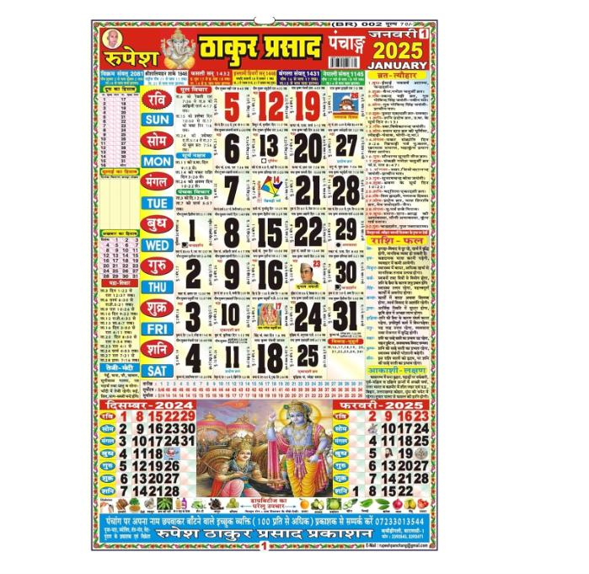
A Panchang is the traditional Hindu almanac.
It provides information such as:
- Date
- Lunar day (Tithi)
- Lunar mansion (Nakshatra)
- Yoga
- Karana
- Sunrise and sunset
- Auspicious timings

Applications
# Source: AI Source: Provided by: [Data Path: Persons Table -> ID Column: 1, Name_En Column: Motasem Essam] -> From: [ChatGPT] on [7/17/2026]
Hindu calendars are used in:
- Religious observances
- Temple ceremonies
- Festivals
- Astrology
- Marriage planning
- Agriculture
- Traditional cultural events

Advantages
# Source: AI Source: Provided by: [Data Path: Persons Table -> ID Column: 1, Name_En Column: Motasem Essam] -> From: [ChatGPT] on [7/17/2026]
Hindu calendars:
- Maintain seasonal alignment.
- Preserve ancient traditions.
- Support religious observances.
- Reflect both lunar and solar cycles.
- Allow accurate festival calculations.

Limitations
# Source: AI Source: Provided by: [Data Path: Persons Table -> ID Column: 1, Name_En Column: Motasem Essam] -> From: [ChatGPT] on [7/17/2026]
Hindu calendars:
- Have multiple regional versions.
- Can differ in festival dates between traditions.
- Are more complex than purely solar calendars.
- Require astronomical calculations and leap-month adjustments.

Comparison with Other Calendar Systems
# Source: AI Source: Provided by: [Data Path: Persons Table -> ID Column: 1, Name_En Column: Motasem Essam] -> From: [ChatGPT] on [7/17/2026]
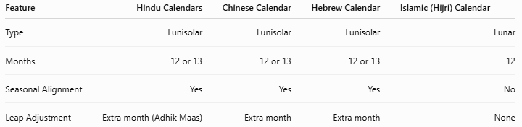
Feature | Hindu Calendars | Chinese Calendar | Hebrew Calendar | Islamic (Hijri) Calendar
Type | Lunisolar | Lunisolar | Lunisolar | Lunar
Months | 12 or 13 | 12 or 13 | 12 or 13 | 12
Seasonal Alignment | Yes | Yes | Yes | No
Leap Adjustment | Extra month (Adhik Maas) | Extra month | Extra month | None

Common Mistakes
- Assuming there is only one Hindu calendar.
- Confusing solar regional calendars (such as the Tamil or Malayalam calendars) with the traditional lunisolar calendars.
- Assuming Hindu festivals occur on the same Gregorian date each year.
- Confusing Adhik Maas (leap month) with a Gregorian leap day.

Key Points
# Source: AI Source: Provided by: [Data Path: Persons Table -> ID Column: 1, Name_En Column: Motasem Essam] -> From: [ChatGPT] on [7/17/2026]
- Hindu Calendars are a family of lunisolar calendars.
- They combine:
  - Lunar months
  - Solar seasonal alignment
- They contain:
  - 12 months in common years
  - 13 months in leap years
- Adhik Maas (leap month) keeps the calendar synchronized with the seasons.
- Major calendar traditions include:
  - Vikram Samvat
  - Shaka Calendar
  - Tamil Calendar
  - Malayalam Calendar
  - Bengali Calendar
- They determine the dates of major Hindu festivals and religious observances.

Conclusion
# Source: AI Source: Provided by: [Data Path: Persons Table -> ID Column: 1, Name_En Column: Motasem Essam] -> From: [ChatGPT] on [7/17/2026]
The Hindu Calendars are a diverse family of traditional lunisolar calendar systems that combine the Moon's monthly cycle with the Sun's yearly cycle. Through the periodic addition of Adhik Maas (a leap month), they maintain seasonal alignment while preserving the rhythm of lunar months. Although regional variations exist, all Hindu calendars serve the essential role of determining religious festivals, auspicious dates, temple ceremonies, and cultural events, making them an enduring part of Hindu religious and cultural life.

